Low Level Design
15 June 2025
01:37 PM

Low-Level Design (LLD) Document – Real-Time Fraud Detection & Notification System

Document Control & Release Notes
- Version: 1.0
- Author: Garima Jhade
- Date: 2025-06-14
- Reviewed by: Garima Jhade
- Status: Draft
- Change Log:
  - v1.0: Initial version with full LLD scope

Table of Contents
- Document Control & Release Notes
- Microservice Overview
- Application Flow
- Service Names and Key Functionality
- API Endpoint Tables
- ER Diagram (Text Representation)
- UML Class Diagrams
- Sequence Diagrams
- Swagger-style API Definitions
- AWS Deployment Architecture
- Non-Functional Requirements
- Design Pattern Usage Table
- Application Flow Explanation
- Logging and Monitoring
- Testing Strategy
- Workflow Summary
- Conclusion

2. Microservice Overview
1. | Microservice | Key Functionality & Capability
2. | Transaction Service | Accepts, validates, persists transactions; publishes events to Kafka
3. | Fraud Detection Service | Applies fraud rules on real-time transactions; publishes fraud alerts
4. | Notification Service | Listens for alerts, integrates with email/SMS gateways to notify users
5. | Dashboard Service | Presents flagged transactions and system status through UI (admin view)

3. Application Flow
- User/API Gateway calls the Transaction Service to submit a transaction.
- Transaction Service stores the data and publishes it to the Kafka topic transactions.
- Fraud Detection Service listens to this topic, applies rules, flags frauds, and emits events to fraud_detected.
- Notification Service listens to fraud_detected, and sends SMS/email alerts.
- Dashboard Service provides a view of all flagged events for administrators.

4. Service Names and Key Functionality
See Microservice Overview above for a detailed mapping of service names to responsibilities.

5. API Endpoint Tables
Transaction Service
Sr. No | Method | Endpoint | Description
1. | POST | /api/transactions | Submits a transaction

Dashboard Service
Sr. No | Method | Endpoint | Description
1. | GET | /api/admin/frauds | Returns flagged fraud transactions

6. ER Diagram (Text Representation)
+----------------+ +---------------------+ +--------------------+
| Transaction | | FlaggedTransaction | | NotificationLog |
+----------------+ +---------------------+ +--------------------+
| id |<------>| transactionId |<------>| flaggedId |
| userId | | ruleViolated | | sentAt |
| amount | | timestamp | | status |
| timestamp | +---------------------+ +--------------------+
+----------------+

7. UML Class Diagrams (Key Services)
+---------------------+ +----------------------+
| TransactionService | | Transaction |
|---------------------| |----------------------|
| +saveTransaction() |<>----->| +id: UUID |
| +publishToKafka() | | +amount: BigDecimal |
+---------------------+ | +timestamp: DateTime |
+----------------------+

+---------------------------+ +--------------------------+
| FraudDetectionService | | FraudRule (interface) |
|---------------------------| |--------------------------|
| +evaluateTransaction() |<>-| +applyRule(Transaction) |
+---------------------------+ +--------------------------+

8. Sequence Diagrams – Fraud Alert Lifecycle
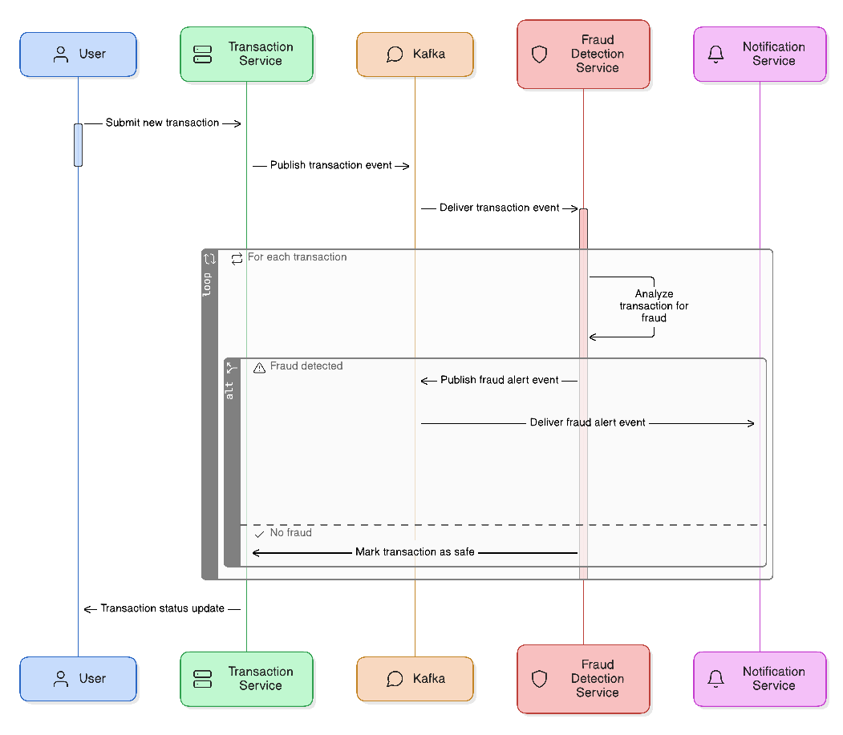

9. Swagger-style API Specification (Partial)
openapi: 3.0.0
info:
title: Fraud Detection System
version: 1.0.0
paths:
/api/transactions:
post:
summary: Submit a transaction
requestBody:
required: true
content:
application/json:
schema:
$ref: '#/components/schemas/Transaction'
responses:
'200':
description: Transaction accepted
components:
schemas:
Transaction:
type: object
properties:
userId:
type: string
amount:
type: number
timestamp:
type: string

10. AWS Deployment Architecture (Proposed)
- ECS Fargate for microservices (containerized)
- Amazon MSK (Managed Kafka) for event streams
- RDS PostgreSQL for relational persistence
- Route 53 + ALB for routing traffic to services
- CloudWatch & X-Ray for observability
- Secrets Manager for securing API keys, DB passwords

11. Non-Functional Requirements
- High Availability: Load balancing and failover
- Scalability: Kafka partitioning, container autoscaling
- Security: Role-based access control, HTTPS, encrypted storage
- Performance: SLA < 2 seconds for alert processing
- Observability: Full tracing + alerting for anomalies

12. Design Pattern Usage Table
Sr. No | Service | Design Pattern | Reason for Use
1. | Fraud Detection Service | Strategy Pattern | Allows dynamically applying different fraud rules based on runtime conditions
2. | Fraud Detection Service | Factory Pattern | Used to create different rule objects from config or DB
3. | Transaction Service | Repository Pattern | To abstract DB operations (CRUD on transactions)
4. | Notification Service | Observer Pattern | Listens to fraud alert events via Kafka and reacts asynchronously
5. | Dashboard Service | MVC Pattern | Standard separation of model, view, and controller logic

13. Application Flow Explanation
All services are loosely coupled via Kafka. Each transaction triggers a cascading flow from ingestion → detection → notification. Real-time feedback is reflected on the UI.

14. Logging and Monitoring
- Structured Logging: JSON with correlation IDs
- Monitoring Tools: Prometheus, Grafana, CloudWatch
- Log Aggregation: Fluentd or Filebeat + ELK
- Alerts: SMS/Slack alerts on failures or performance degradation

15. Testing Strategy
- Unit Tests: JUnit, Mockito
- Integration Tests: Spring Boot, Embedded Kafka, TestContainers
- Contract Tests: Pact
- E2E Tests: Selenium or Cypress for dashboard UI

16. Workflow Summary
- Kafka-based message pipeline for real-time fraud detection
- Notification service triggers external gateways
- Dashboard consumes fraud data and reflects updates

17. Conclusion
This Low-Level Design serves as a solid foundation for building an enterprise-grade, real-time fraud detection system. Leveraging Kafka, Spring Boot, and modern cloud-native architecture ensures extensibility, robustness, and speed. Next steps involve implementation, CI/CD pipeline setup, and Kubernetes/infra deployment planning.

